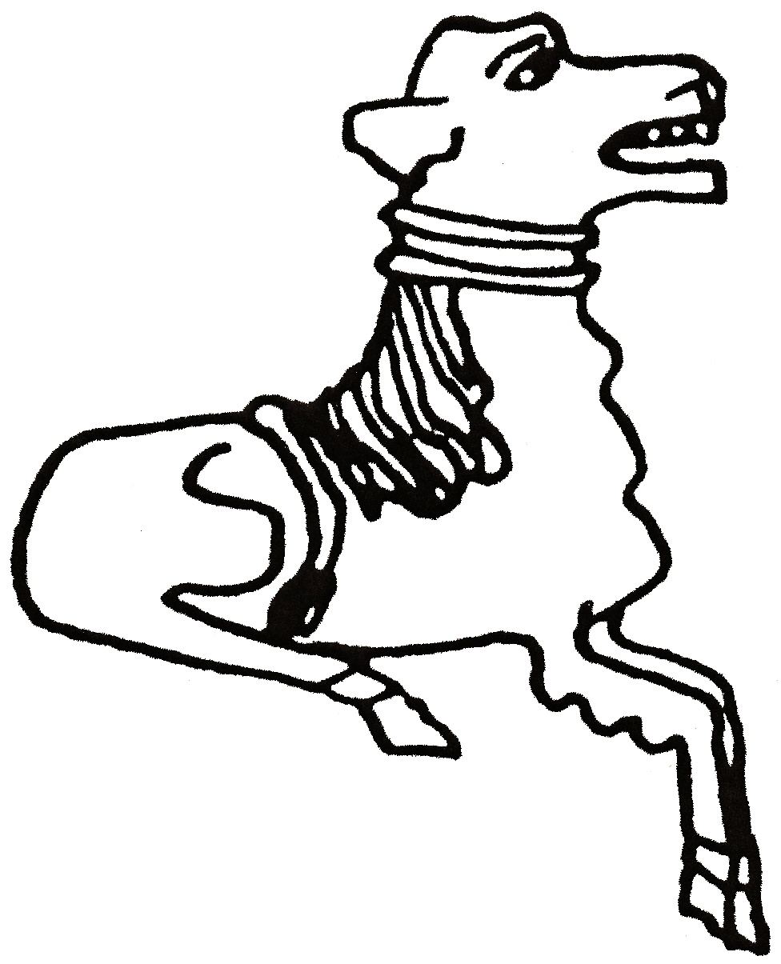 CODICOTE LOCAL HISTORY SOCIETY
James 1st
Hunting & Hawking in Hertfordshire

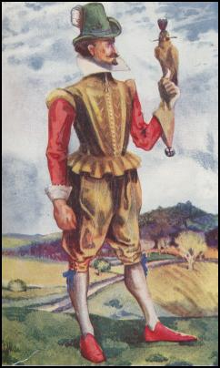

Presentation by Alan Thompson
This talk is on the many connections that James had with Hertfordshire. He built a palace at Theobalds Park, a hunting lodge at Royston and went hunting & hawking across the county.

Codicote Peace Memorial Hall
Tuesday 11 February 2014 7.30 pm for 8.00 pm
FREE entry for members and just £3 for visitors
Tel: 01438-821849 www.codicotehistory.org.uk
Explore your interest in history today!

