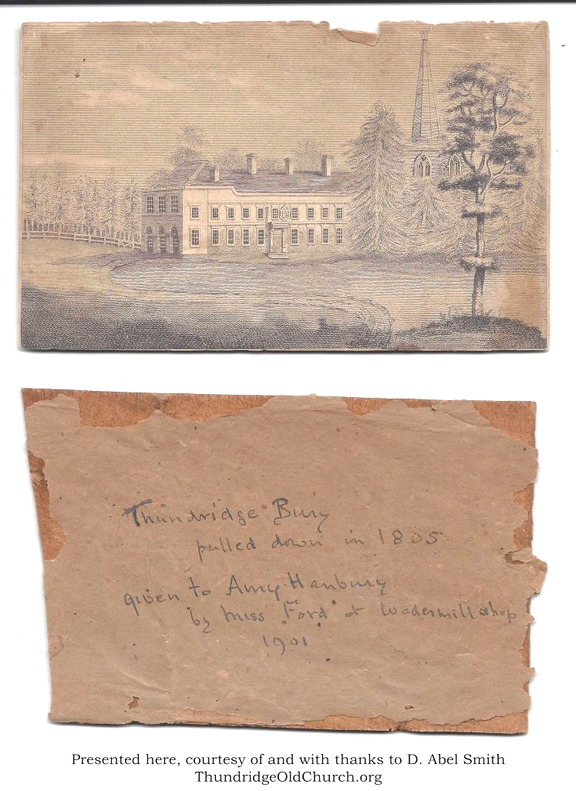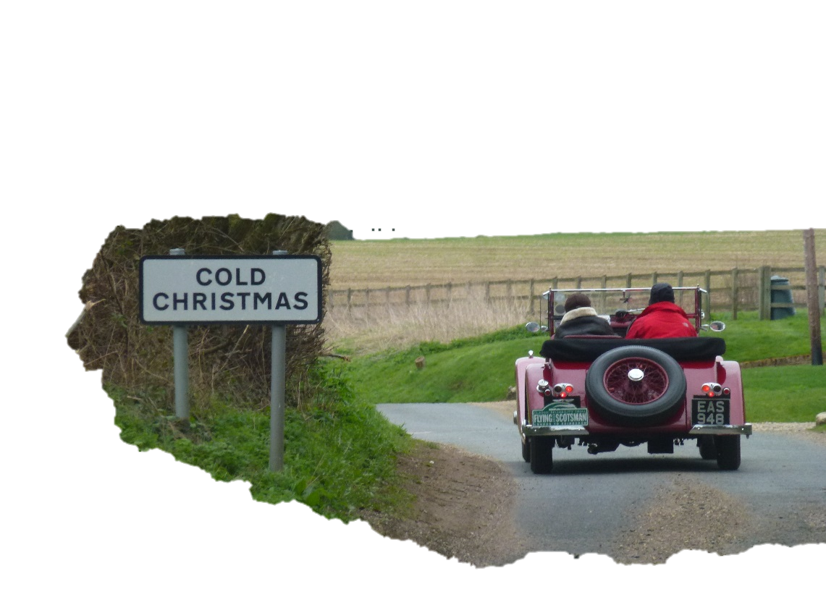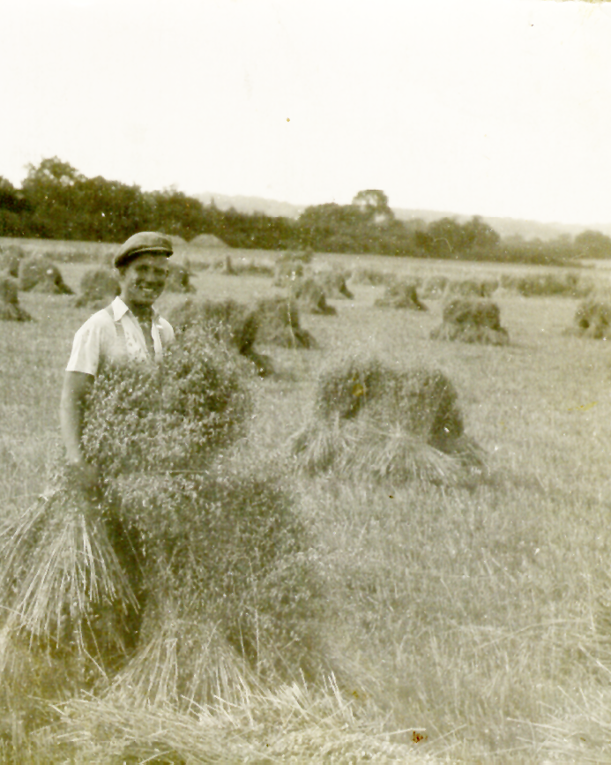

**By** **Emma** **Blowers**

**Revealing Thundridge’s UplandS**

**Swapping Lies Around Cold Christmas**