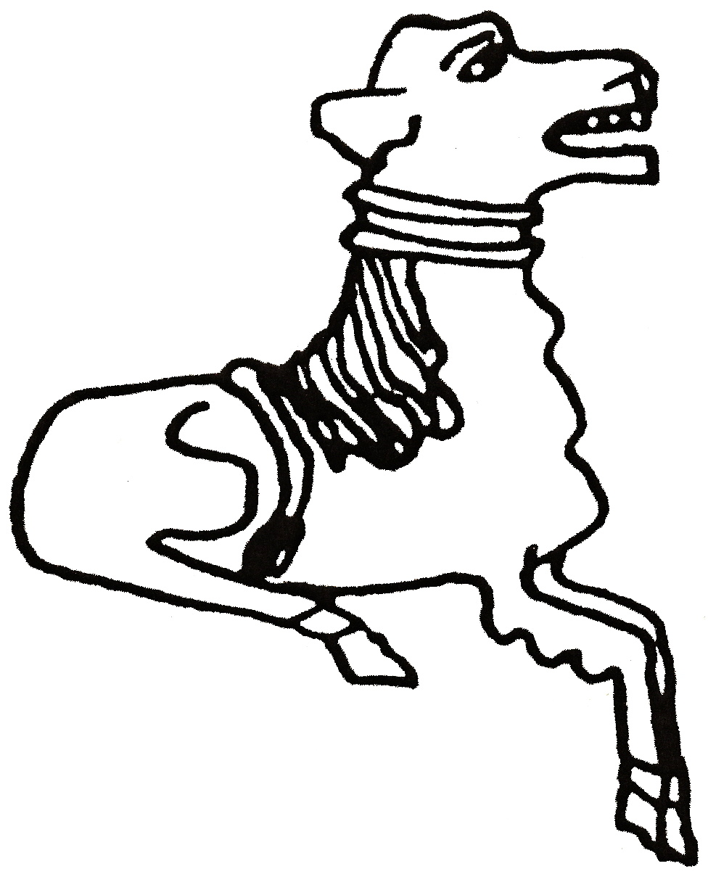 CODICOTE LOCAL HISTORY SOCIETY
Early Days of Steam Power on the Farm

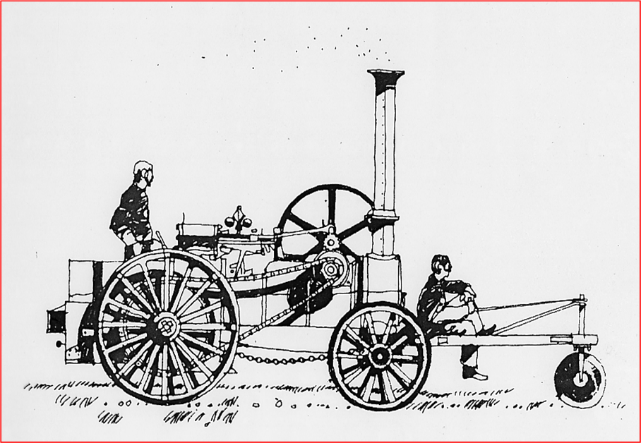
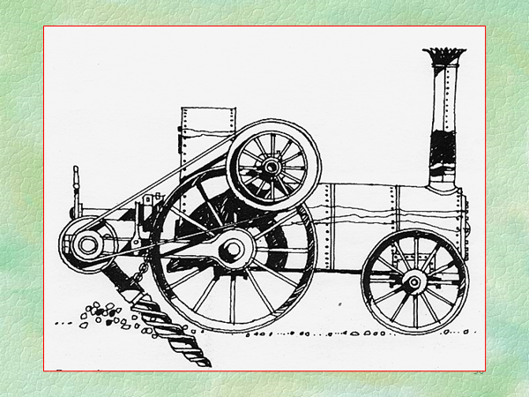
A talk by Tom Doig
This informative & amusing talk traces the rise and fall of steam in agriculture and looks at its possible resurrection. Farm life in the early days of steam power was an exciting and, sometimes, frightening experience. This talk looks at steam’s varied uses – some successful … and others unfortunately not! Amongst other machines, we’ll meet the Derby Walking Digger (said to do the work of 10 men), but also the uncontrollable Romain Croskill cultivator …

Peace Memorial Hall, Tues 8 Feb 2022 8 pm

FREE entry for members and just £3 for visitors
For more info, contact Nicholas Maddex at nkmaddex@btinternet.com
www.codicotehistory.org.uk #codicotehistory
 We love Codicote
Explore your interest in history today!

