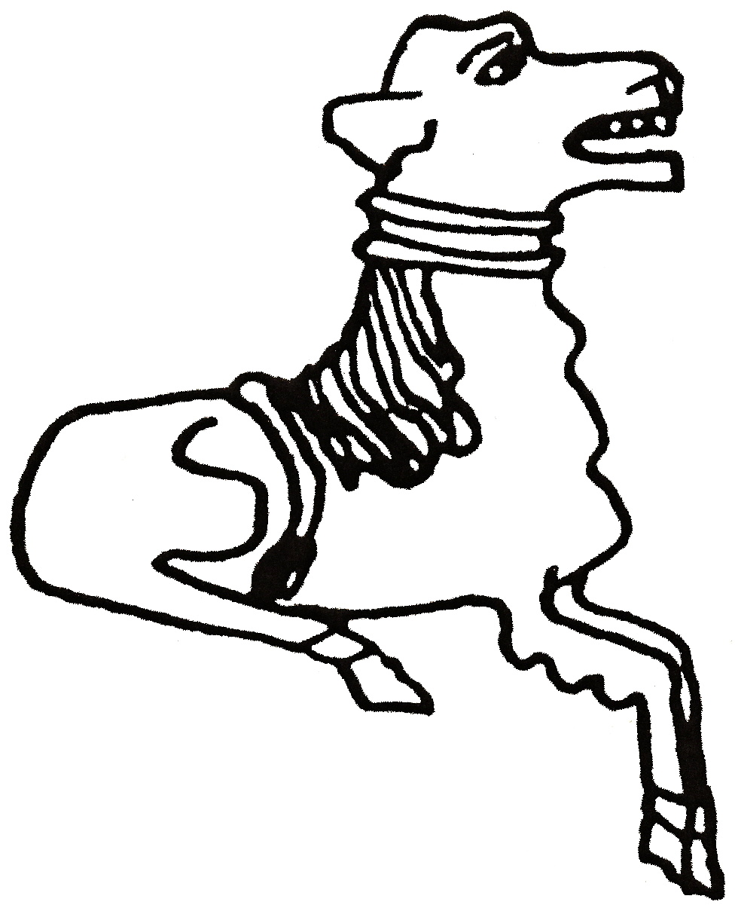 CODICOTE LOCAL HISTORY SOCIETY
Calling Time in St Albans

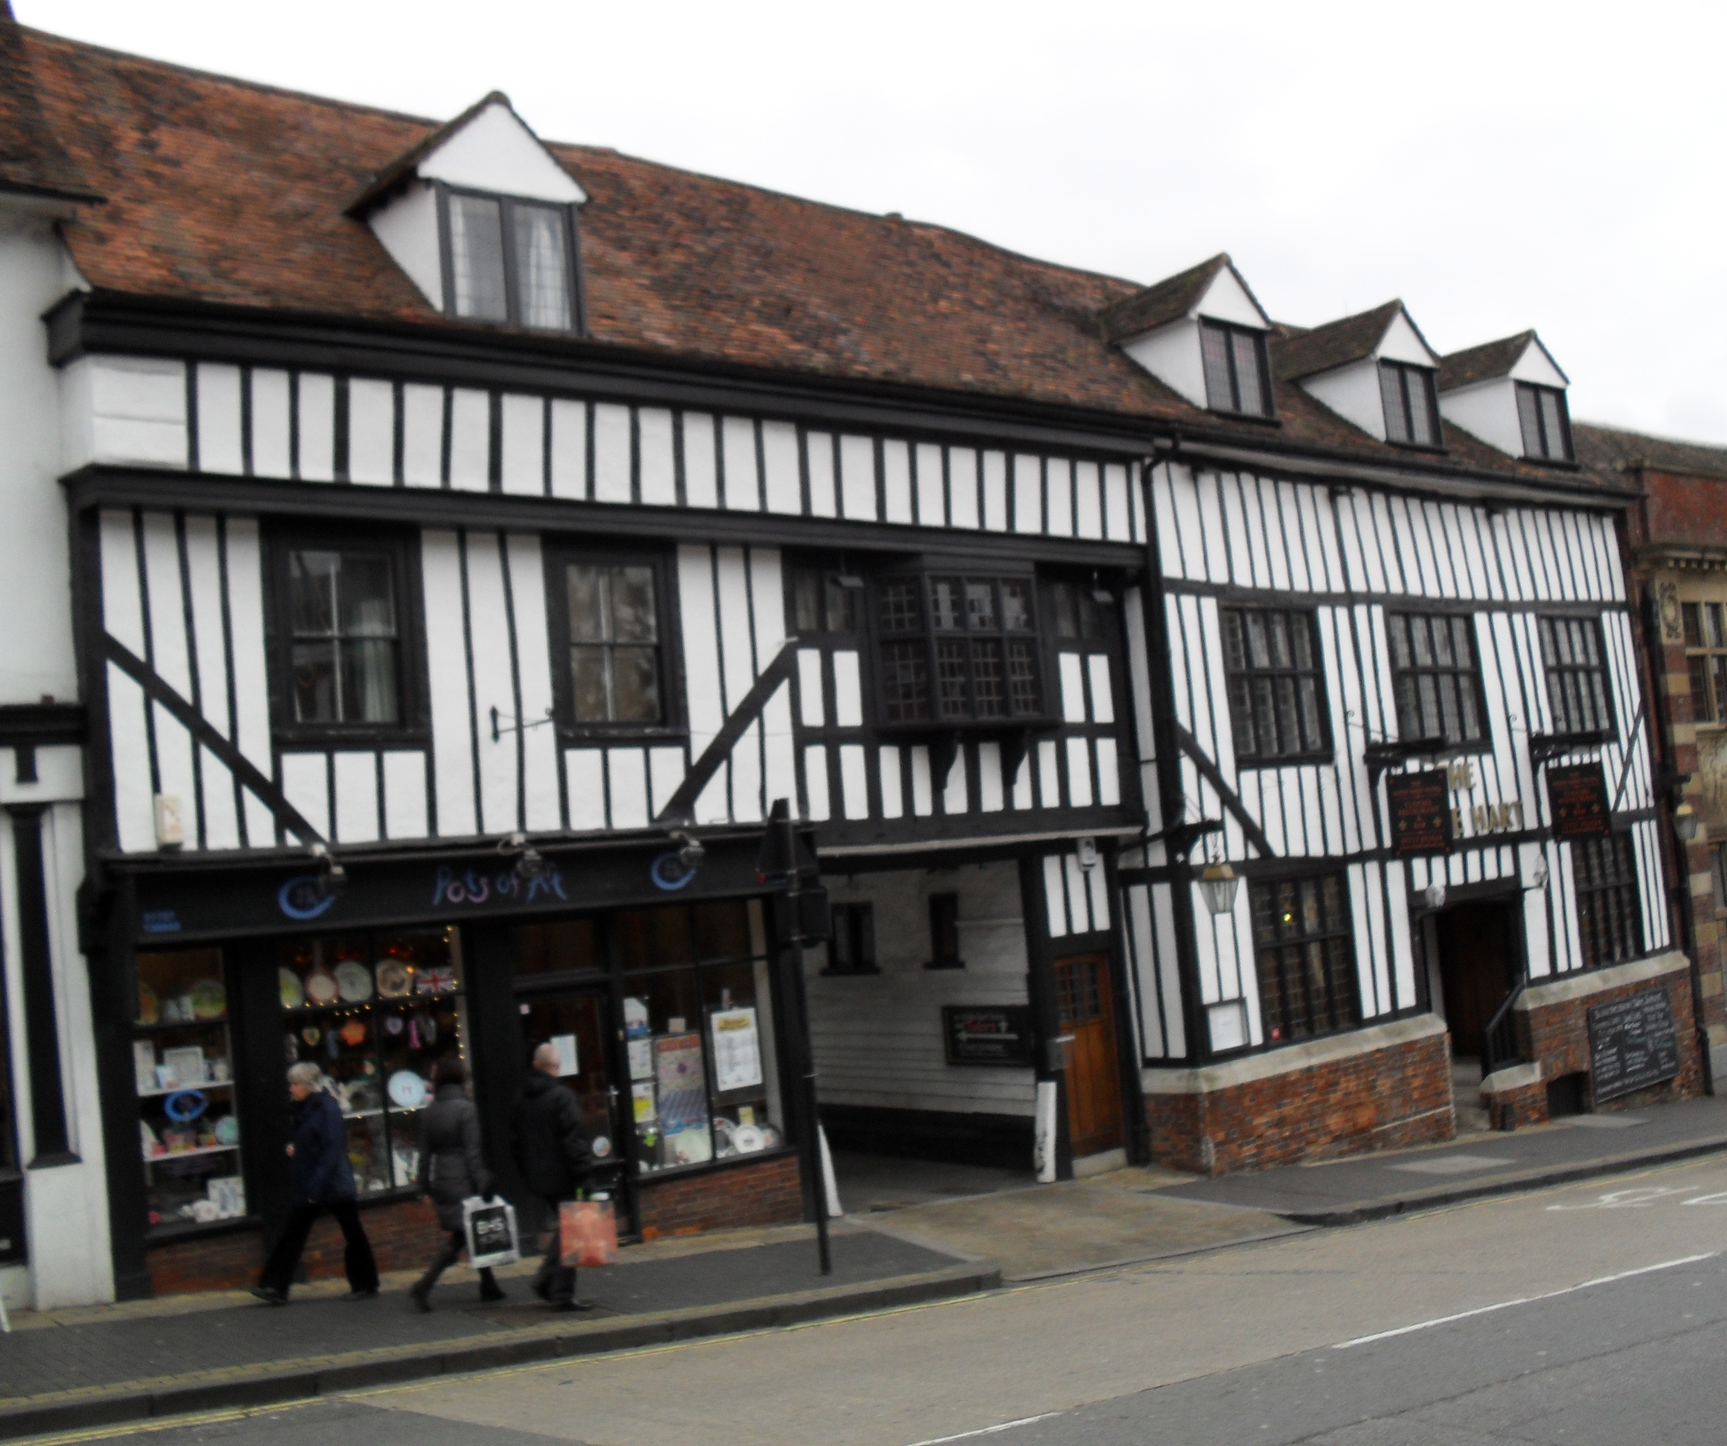
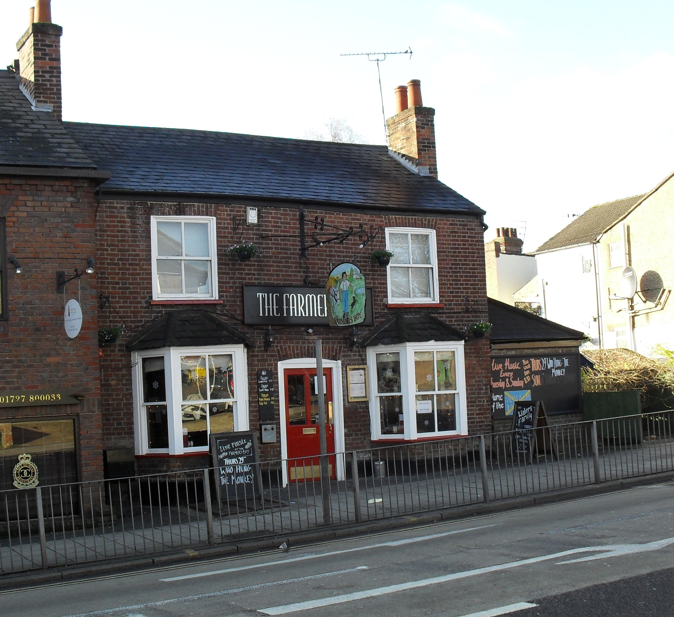
by Jon Mein
Pubs will soon be trading as normal, which makes this month’s talk very apt.

Historically St Albans has had dozens of public houses – in 1870 there was one pub for every 84 inhabitants. This month’s Zoom talk will firstly look at why there were so many. We’ll then check out the causes for the decline that set in from the late 1870s until 1914.

Zoom Talk, Tuesday 11 May 2021 8 pm

FREE entry for members and just £3 for visitors
For more info and the Zoom link, contact
Nicholas Maddex at nkmaddex@btinternet.com
www.codicotehistory.org.uk #codicotehistory
Explore your interest in history today!

