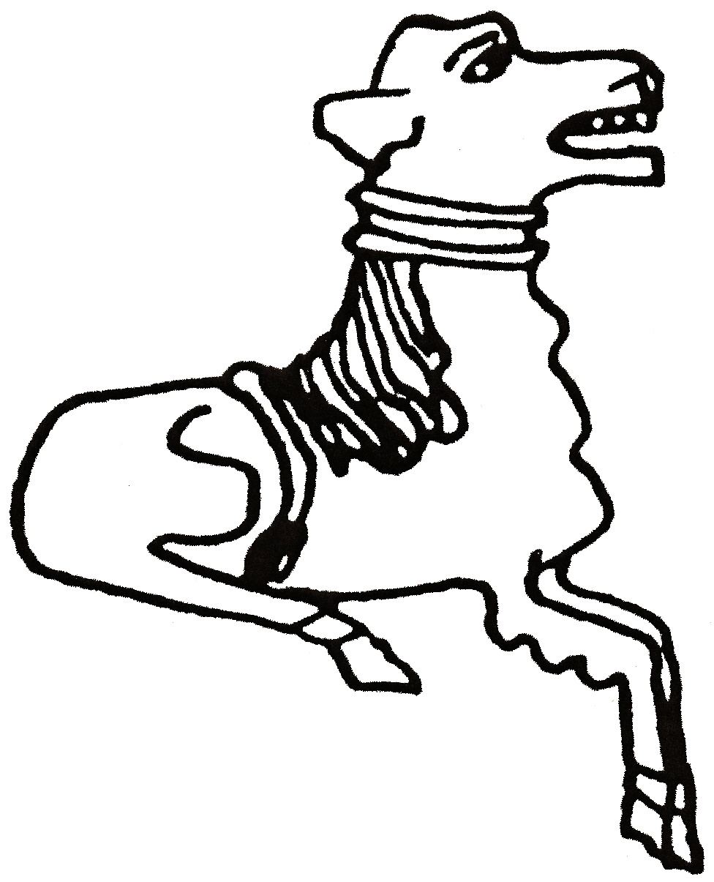 CODICOTE LOCAL HISTORY SOCIETY




Zoom Talk, Tuesday 13 April 2021 8 pm

FREE entry for members and just £3 for visitors
For more info and the Zoom link, contact
Nicholas Maddex at nkmaddex@btinternet.com
www.codicotehistory.org.uk #codicotehistory
Explore your interest in history today!

