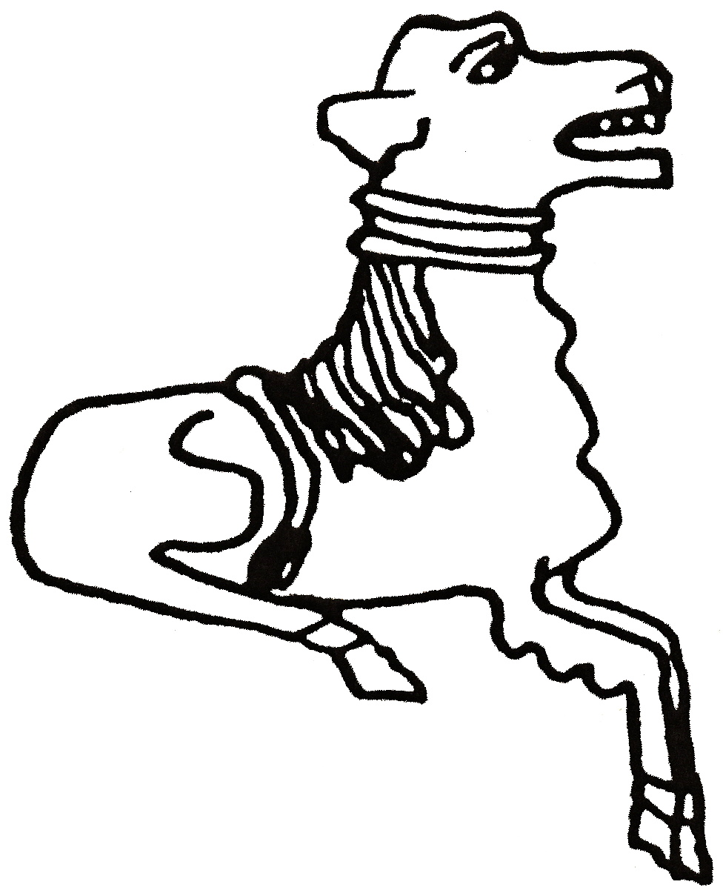 CODICOTE LOCAL HISTORY SOCIETY
Life in Codicote in the 1820s & 30s,
the diary of Thomas Bigg

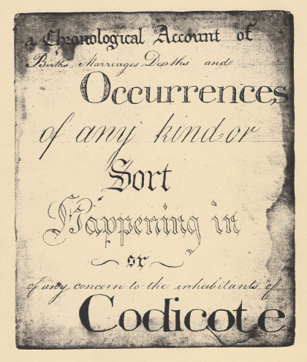
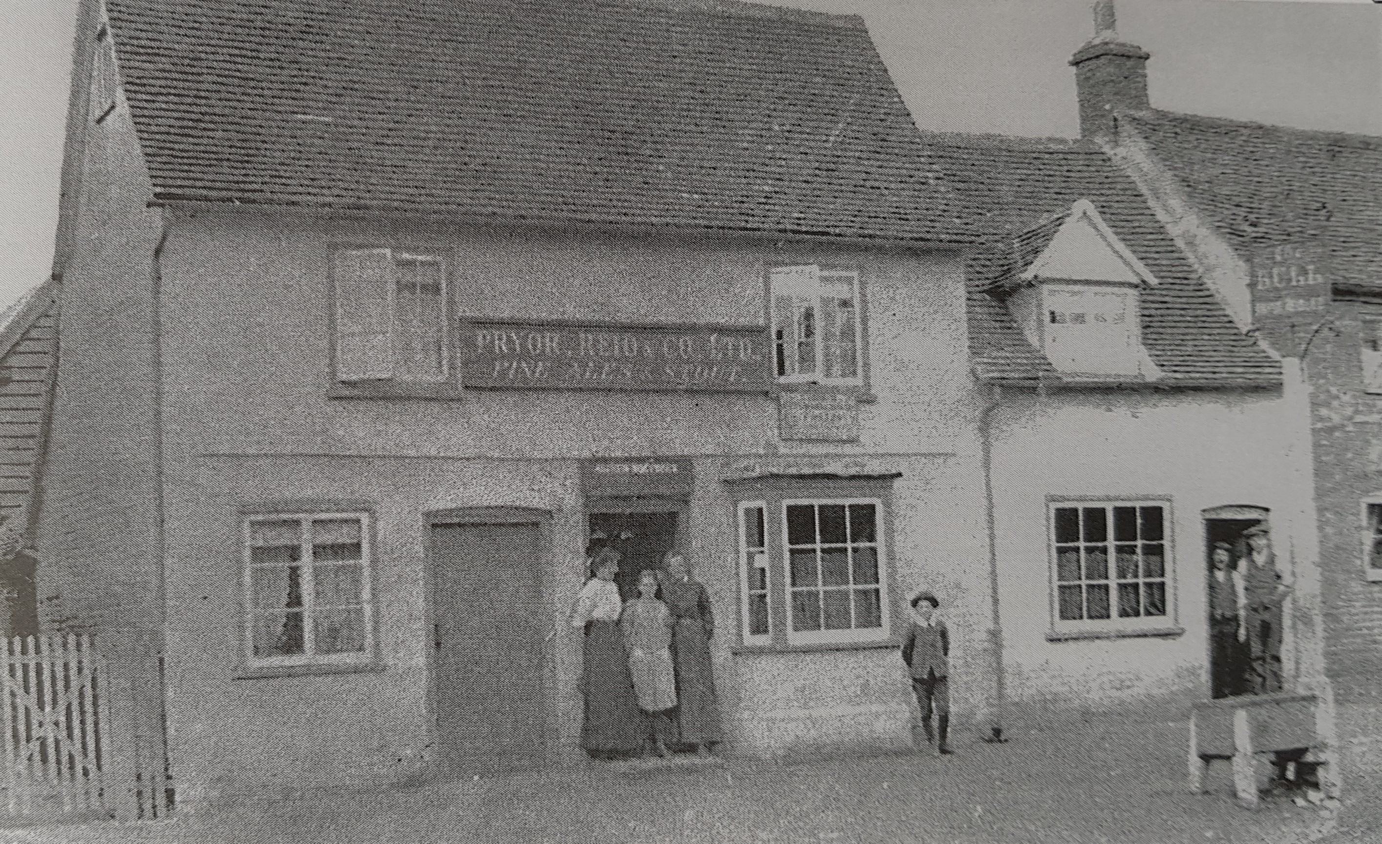
by Nicholas & Frances Maddex, and Lucy Alexander
What was everyday life like in Codicote in the 1820s and 30s? Fortunately, Thomas Bigg, school teacher and publican of the Bull Inn kept a diary which gives a remarkable insight into those years. This month’s Zoom comprises diary readings, that explore the local and the national - from trivial village life to an alleged murder, from a national petition against Catholics to a country-wide outbreak of cholera.

Zoom Talk, Tuesday 3 March 2021 8 pm

FREE entry for members and just £3 for visitors
Tel: 01438-821849 www.codicotehistory.org.uk
Explore your interest in history today!

