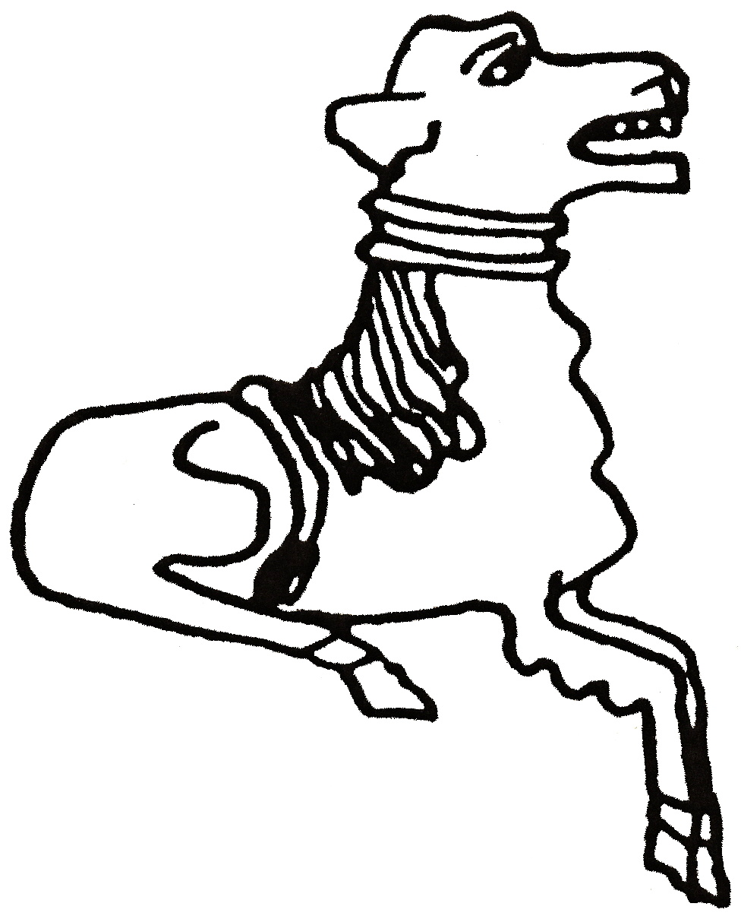 CODICOTE LOCAL HISTORY SOCIETY
Stats that speak: a village story
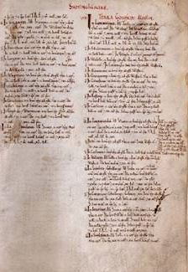 |  |  | 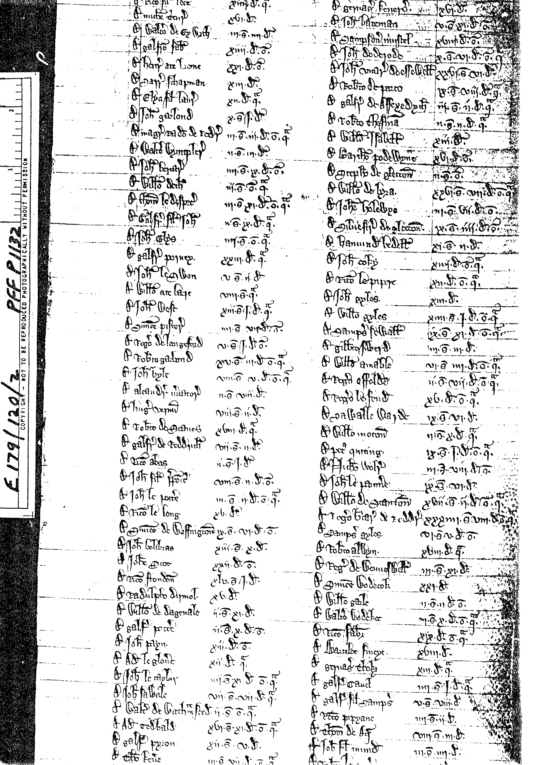
Presentation by David Short

Codicote’s population has grown and shrunk over the ages. The Black Death, industrialisation and late 20th century developments have all had significant impacts. This talk traces the trends, using the Domesday Book, Census returns and other sources to compare Codicote and its neighbours.

Codicote Peace Memorial Hall
Tuesday 13 February 2018 7:30 pm for 8 pm
FREE entry for members and just £3 for visitors

Tel: 01438-821849 www.codicotehistory.org.uk
Explore your interest in history today!

