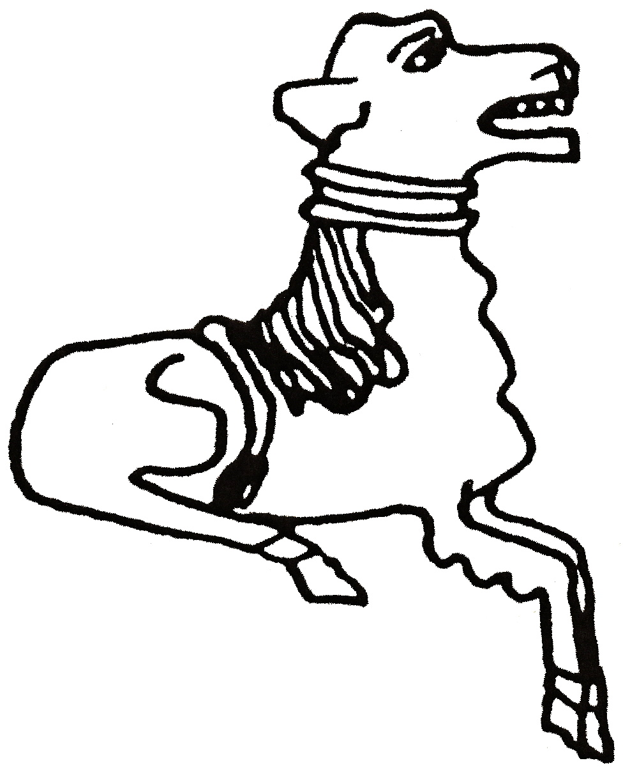 CODICOTE LOCAL HISTORY SOCIETY
Policing Hertfordshire before ‘the police’
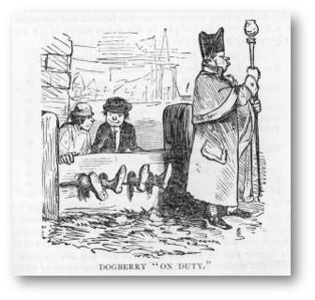 | 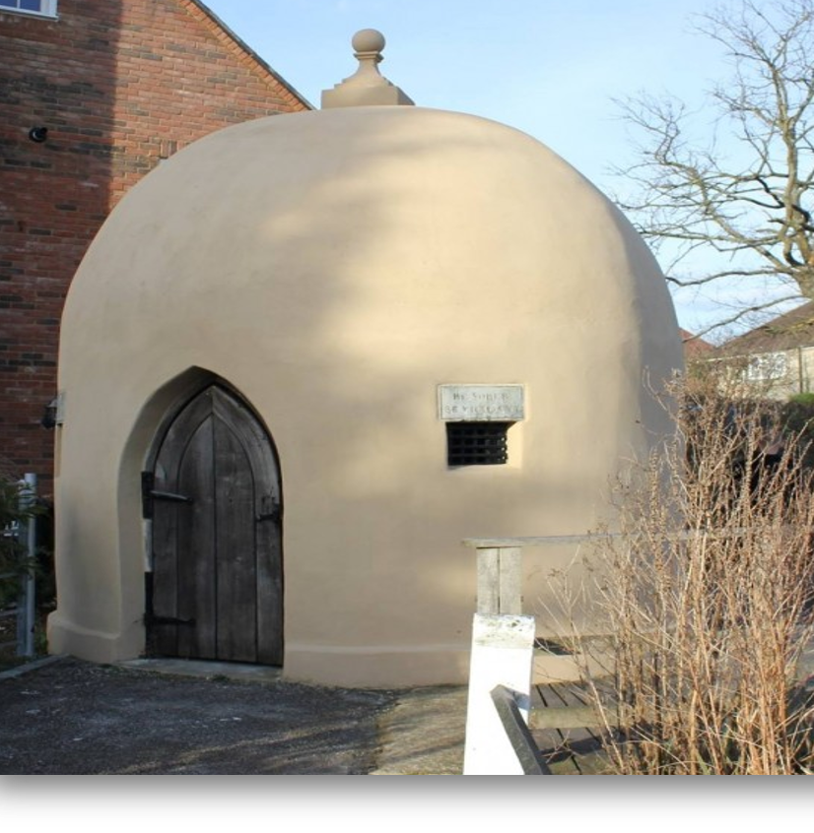

Presentation by Elaine Saunders, The Open University

In 1841, Hertfordshire created its county constabulary, but how was order maintained beforehand? This talk will shed light on ancient systems of policing, who Codicote's constables were, how they took office and what their duties entailed. It also discusses how policing changed in the early 19th century and the reasons why Hertfordshire felt it needed a constabulary.

Codicote Peace Memorial Hall
Tuesday 14 November 2017 7:30 pm for 8 pm
FREE entry for members and just £3 for visitors

Tel: 01438-821849 www.codicotehistory.org.uk
Explore your interest in history today!

