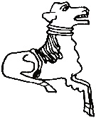 CODICOTE LOCAL HISTORY SOCIETY
Digging Archaeology Test Pits in Codicote Volunteers Wanted - Sat 8th & Sun 9th July
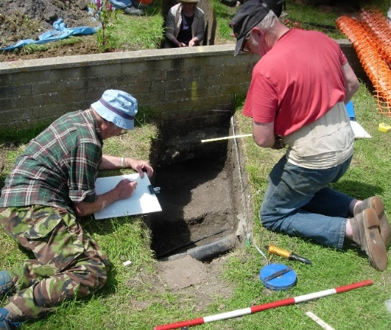 | 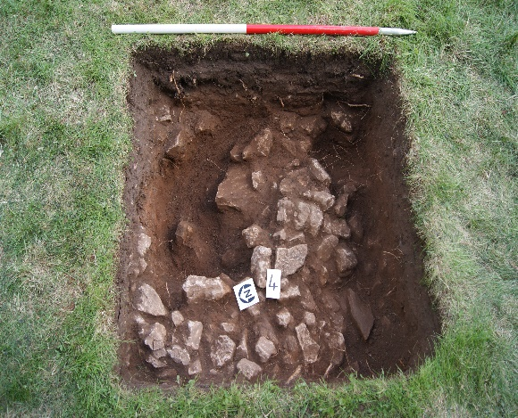

Interested in exploring Codicote’s hidden past?

We’re digging 1m x 1m test pits at The Goat and elsewhere in the village centre. We want to discover more about Codicote, its past inhabitants and their everyday lives. Who knows what Edwardian, Victorian or Medieval objects lie just under the ground?

We need volunteers:

- to dig the test pits
and
- to collate and clean finds

All ages can take part. There’s some basic training on Tues 27 June evening, led by Keith Fitzpatrick-Matthews, North Herts Archaeologist. No problem if you can’t attend, we’ll provide support and digging tools on 8-9 July.

To find out more, contact:

Nicholas Maddex on 01438-821849 or nkmaddex@btinternet.com

www.codicotehistory.org.uk
Explore your interest in history today!

