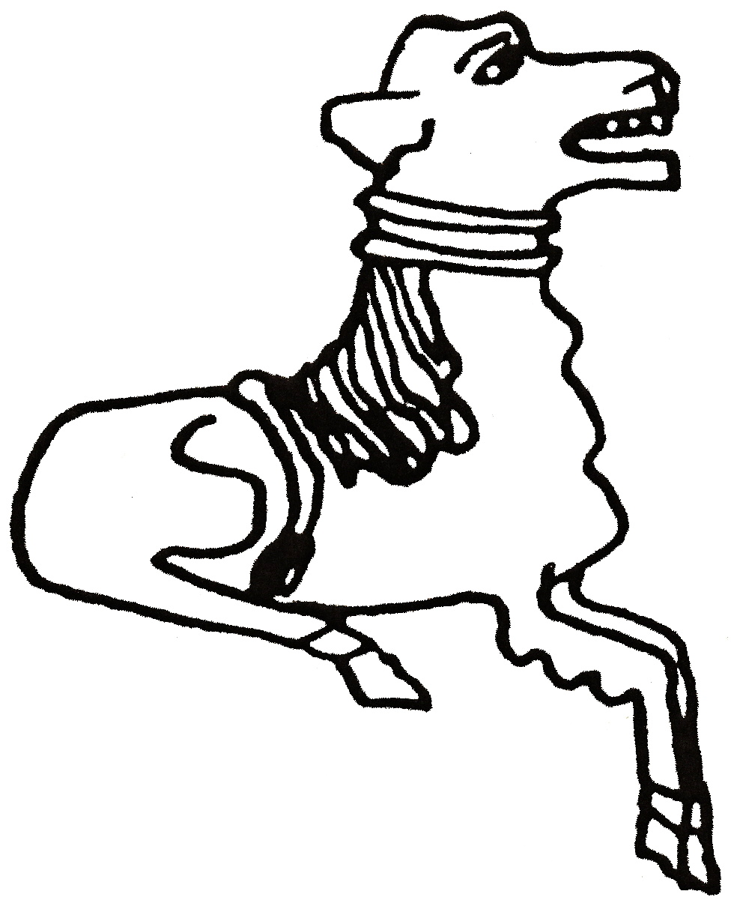 CODICOTE LOCAL HISTORY SOCIETY
Family History Day – Codicote Pubs

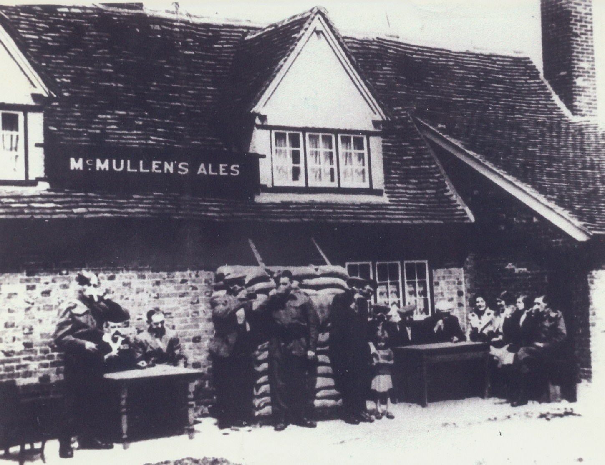
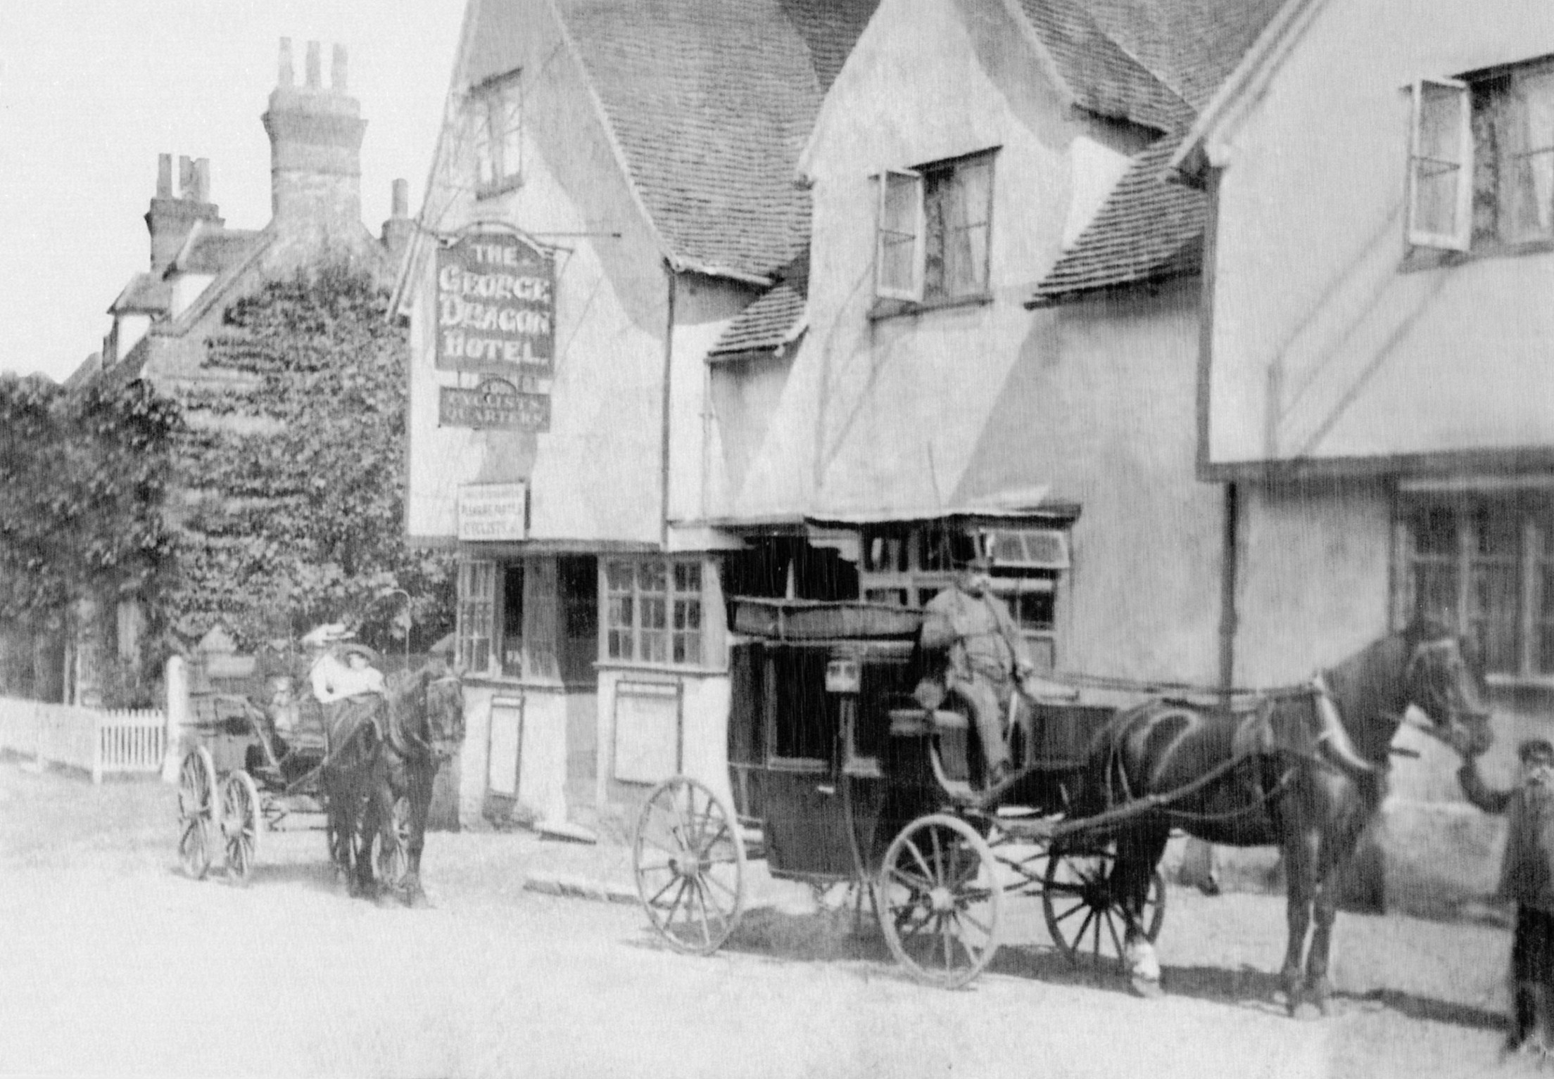

Interested in your ‘locals’ – today’s & from the past?
Want to know more of the history of Codicote?

Come to the Family History Day for an exhibition of photos, items and information on the many pubs in Codicote’s history – from the 1st recorded premises in 1279 to the present day. Local books and light refreshments for sale plus information on our planned Codicote Archaeology Test Pit dig (8-9 July).

Codicote Peace Memorial Hall
Sat 22 April 2017 10 am to 4 pm

Admission £1 for adults, accompanied children free
Tel: 01438-821849 www.codicotehistory.org.uk
Explore your interest in history today!

