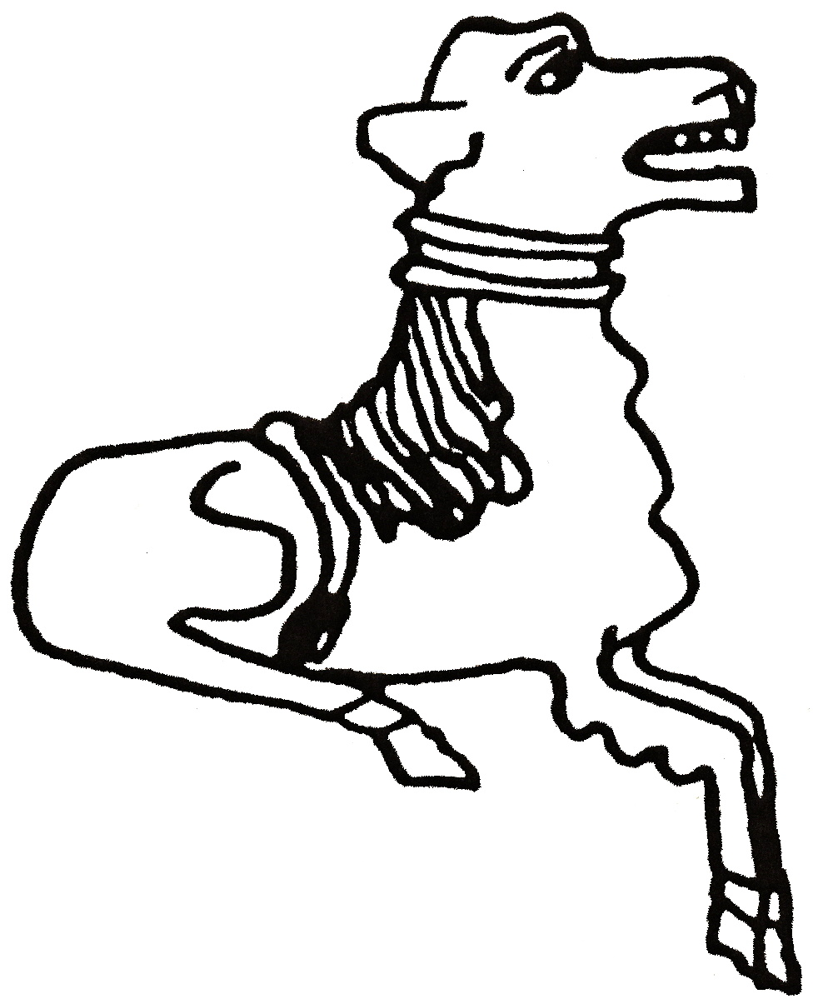 CODICOTE LOCAL HISTORY SOCIETY

Restoring the platform at Wheathampstead Station

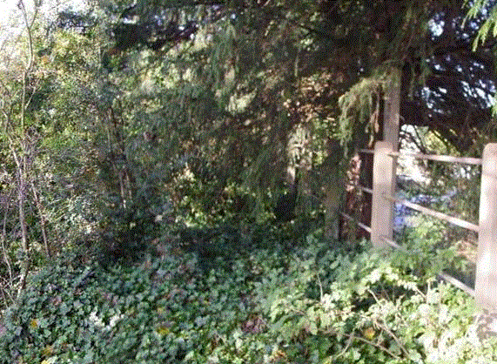 | 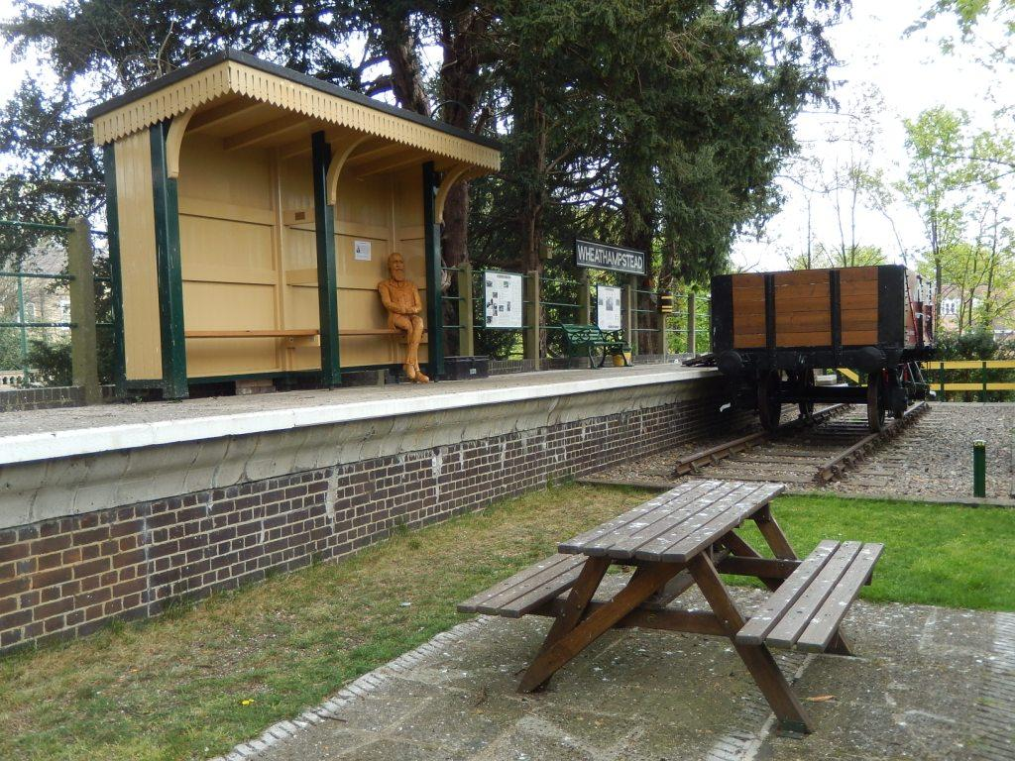

A presentation by Patrick McNeill

Wheathampstead Station platform fell derelict after the line was closed in 1965, a victim of the Beeching Report. Since 2009, volunteers have restored the platform brilliantly as an ‘outdoor museum’ on the Village Centre Heritage Trail. This talk tells the story of the dedicated restoration work, and the trials and tribulations involved.

Codicote Peace Memorial Hall
Tuesday 14 February 2017 7:30 pm for 8 pm

FREE entry for members and just £3 for visitors
Tel: 01438-821849 www.codicotehistory.org.uk
Explore your interest in history today!

