Hertfordshire award for Colin Barker
for his outstanding contribution to local history in Codicote

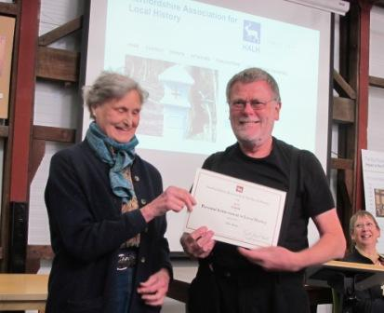

On Sat 14 May 2016, at their Spring Meeting, the Hertfordshire Association for Local History (HALH) presented Colin Barker with their Award for Personal Achievements. HALH presents these awards in recognition of outstanding contributions to local history.
Colin has been a key member of the Codicote Local History Society (CLHS) committee since its foundation 36 years ago and is a worthy recipient of this honour. Five years ago, when CLHS took over the Community Hall, behind the Peace Memorial Hall in Codicote High Street, Colin raised funds and organised volunteers to renovate this run-down, corrugated iron building. We now have a bright, welcoming space to display our exhibits at our monthly Sunday afternoon openings, where everyone can look through photo archives and discuss the local artefacts over a cup of tea and a slice of cake. Colin’s hard work has helped provide this platform to promote interpretation of Codicote’s history and to make the past more meaningful to us all. The event was featured in The Comet, Stevenage’s local paper.

