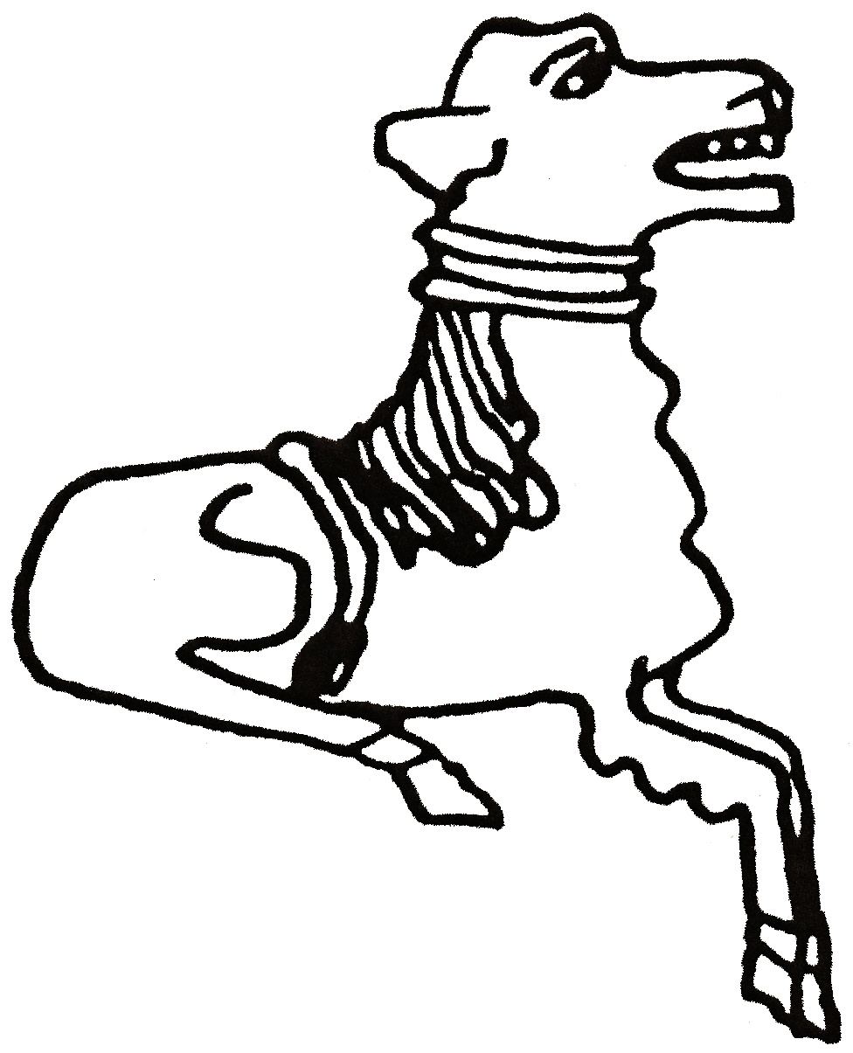 CODICOTE LOCAL HISTORY SOCIETY
A rich Roman burial from Kelshall, North Herts

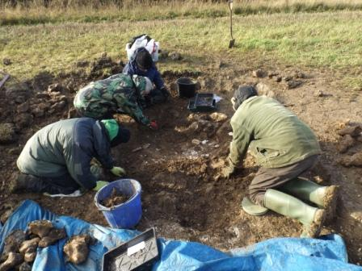
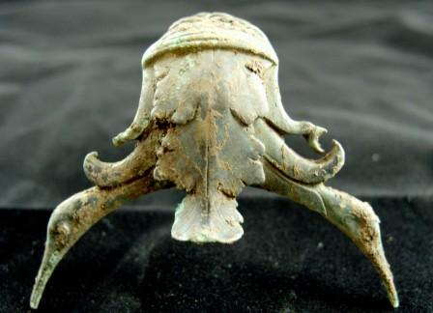
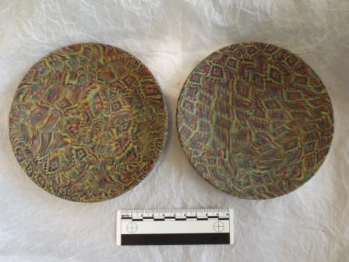 | 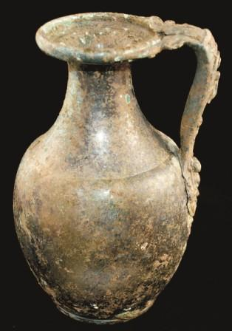

3 special presentations by Phil Kirk,
Keith Fitzpatrick Matthews & Chris Lockyer
A chance metal detector find revealed beautiful Roman glass & metal items, unique in Britain. This talk explores the thrill of discovery, the importance of the finds and what post-excavation surveys of the area reveal about Roman life.

Codicote Peace Memorial Hall
Tuesday 11 October 2016 7:30 pm for 8 pm

FREE entry for members and just £3 for visitors
Tel: 01438-821849 www.codicotehistory.org.uk
Explore your interest in history today!

