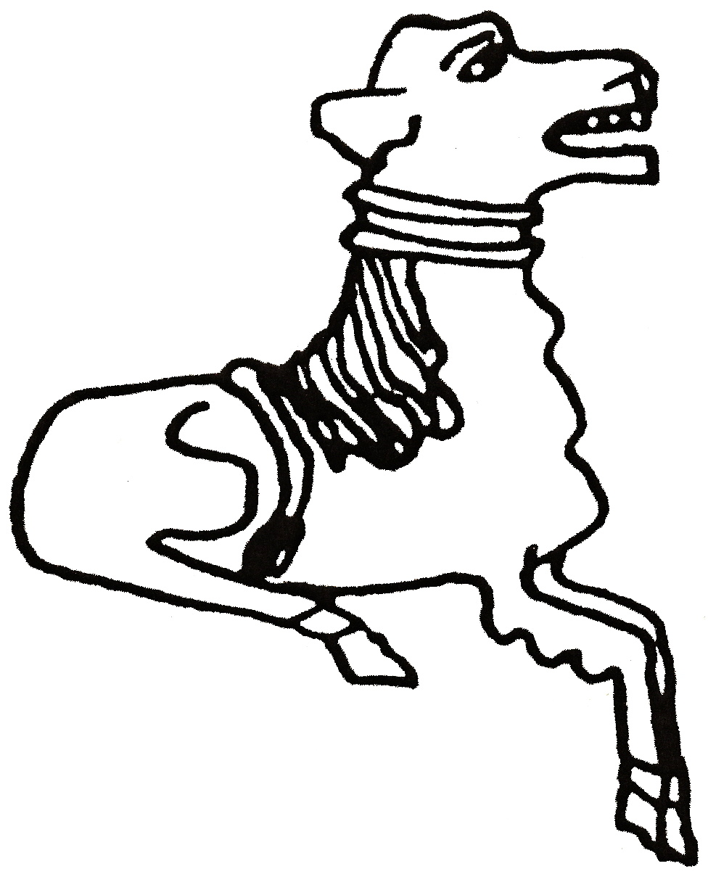 CODICOTE LOCAL HISTORY SOCIETY
Wind, Water & Steam: The Mills of Hertfordshire

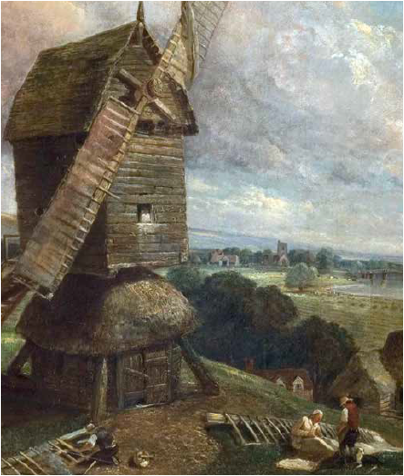
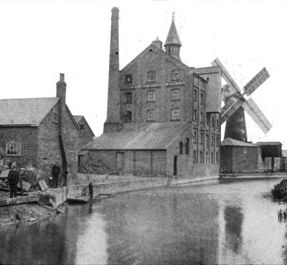

Presentation by Hugh Howes
Hertfordshire has a rich milling heritage that played a key role in its growth and prosperity - from the first water mills before Domesday, through medieval windmills and onto later steam-driven ones. Mills fulfilled many roles - grinding corn, spinning silk, paper making – and Codicote had its own mill for fulling cloth.

Codicote Peace Memorial Hall
Tuesday 13 Sept 2016 7:30 pm for 8 pm

FREE entry for members and just £3 for visitors
Tel: 01438-821849 www.codicotehistory.org.uk
Explore your interest in history today!

