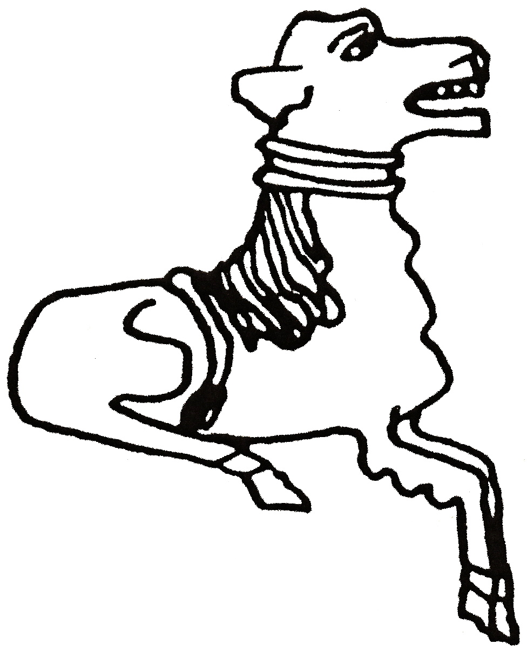 CODICOTE LOCAL HISTORY SOCIETY
The American Civil War (1861-65)

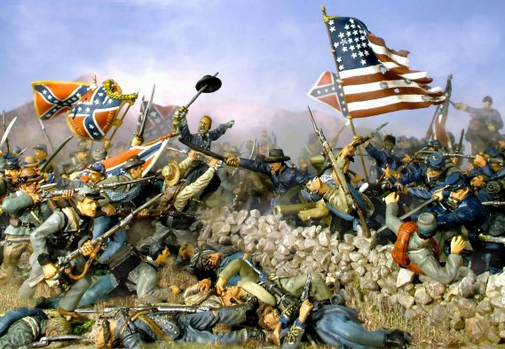

Presentation by Roger Dixey

Fought to determine the survival of the Union or independence for the South, this devastating war left 750,000 Americans dead, the South’s infrastructure destroyed - and slavery abolished.

This month’s meeting also includes the launch of a brand new publication,  ‘The Archaeology of Codicote: Cuthhere’s People’s Cottages’ and our AGM. | 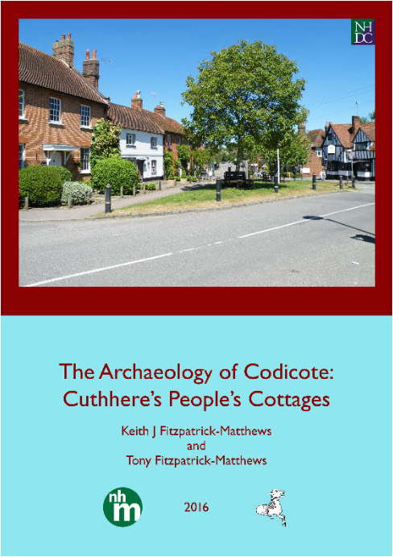

Codicote Peace Memorial Hall
Tuesday 8 March 2016 7:30 pm for 8 pm

FREE entry for members and just £3 for visitors
Tel: 01438-821849 www.codicotehistory.org.uk
Explore your interest in history today!

