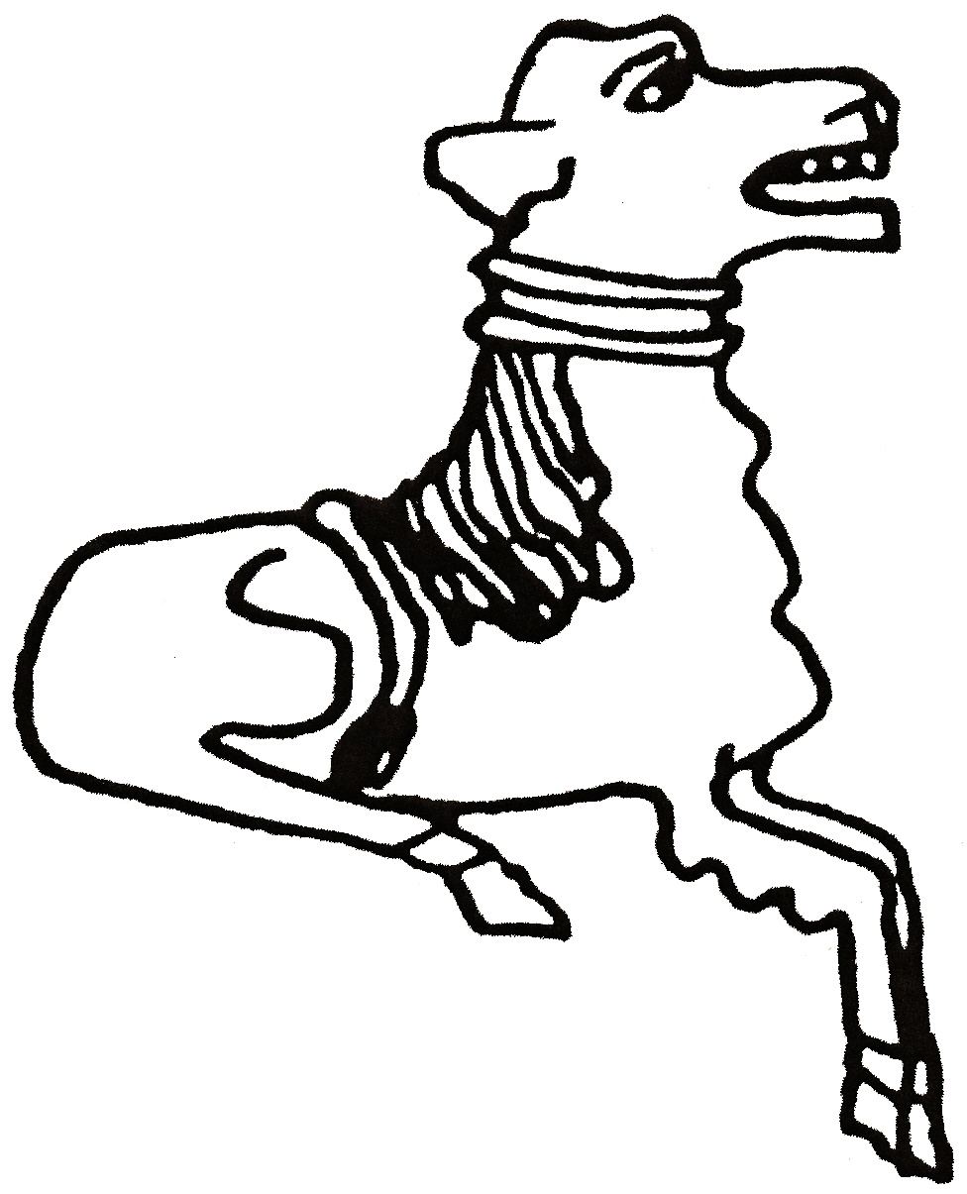 CODICOTE LOCAL HISTORY SOCIETY
The History of Beekeeping

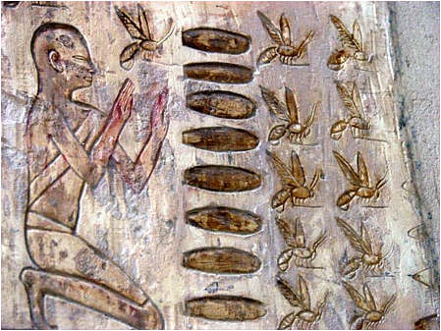
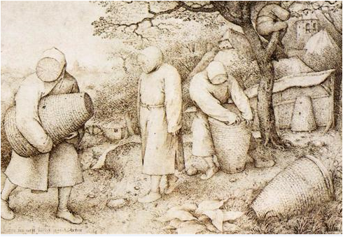
Presentation by Sue Parkins
Honey has been harvested from bees for thousands of years. This talk covers the history and practice of beekeeping from ancient times to the present day. A short film about E H Taylor's of Welwyn, who used to supply beekeeping equipment, will be included. There will also be an opportunity to taste some local honey.
Codicote Peace Memorial Hall
Tuesday 10 Feb 2015 7.30 pm for 8.00 pm
FREE entry for members and just £3 for visitors
Tel: 01438-821849 www.codicotehistory.org.uk
Explore your interest in history today!

