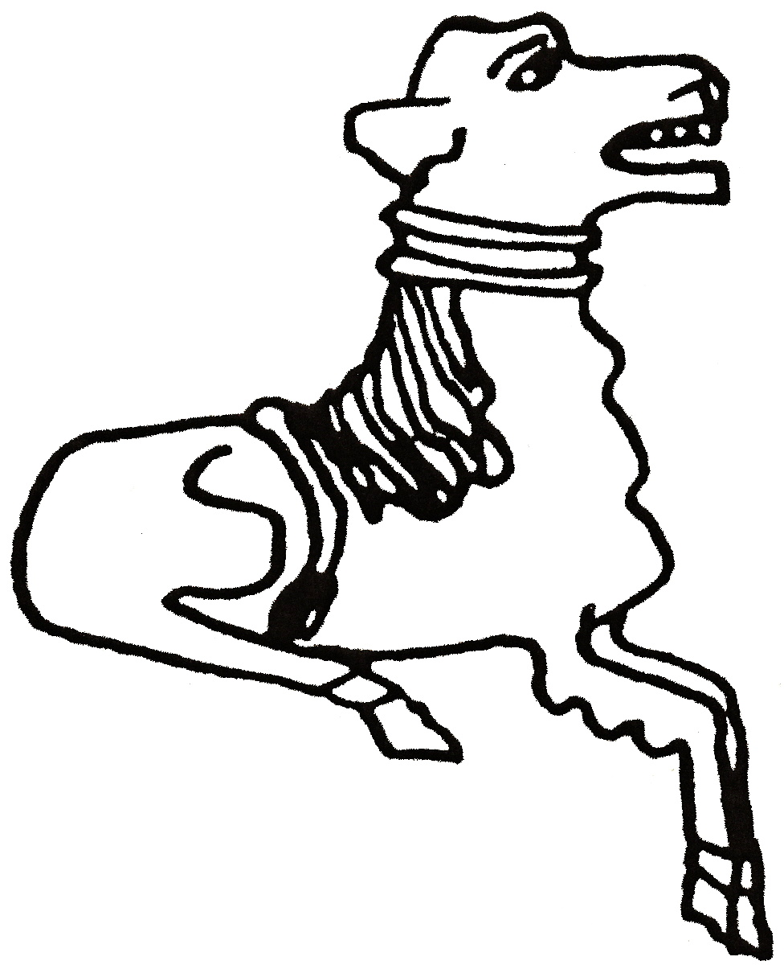 CODICOTE LOCAL HISTORY SOCIETY
The Early Days of Cricket
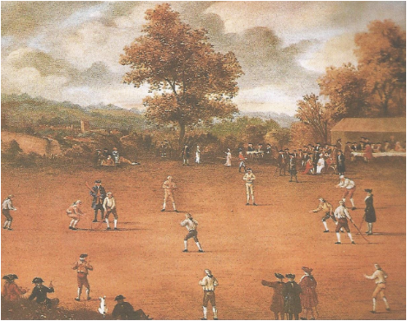
Presentation by Richard Agarwala
An overview of the early history of cricket from the time of Edward I, through to the Tudors, Stuarts, and Georgians up to the formation of the MCC, with emphasis on the social history of cricket.

Codicote Peace Memorial Hall
Tuesday 8 October 7.30 pm for 8.00 pm
FREE entry for members and just £3 for visitors
Tel: 01438-821849 www.codicotehistory.org.uk
Explore your interest in history today!

