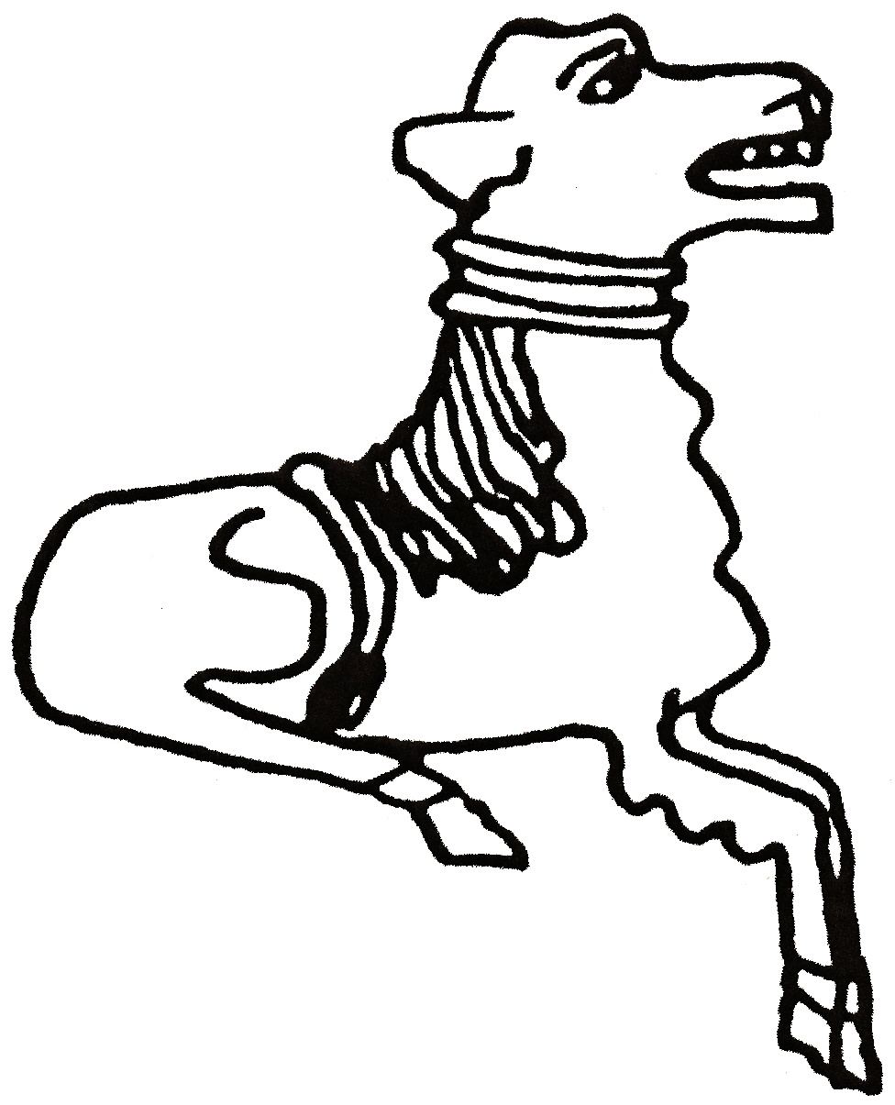 CODICOTE LOCAL HISTORY SOCIETY
“Thatching”

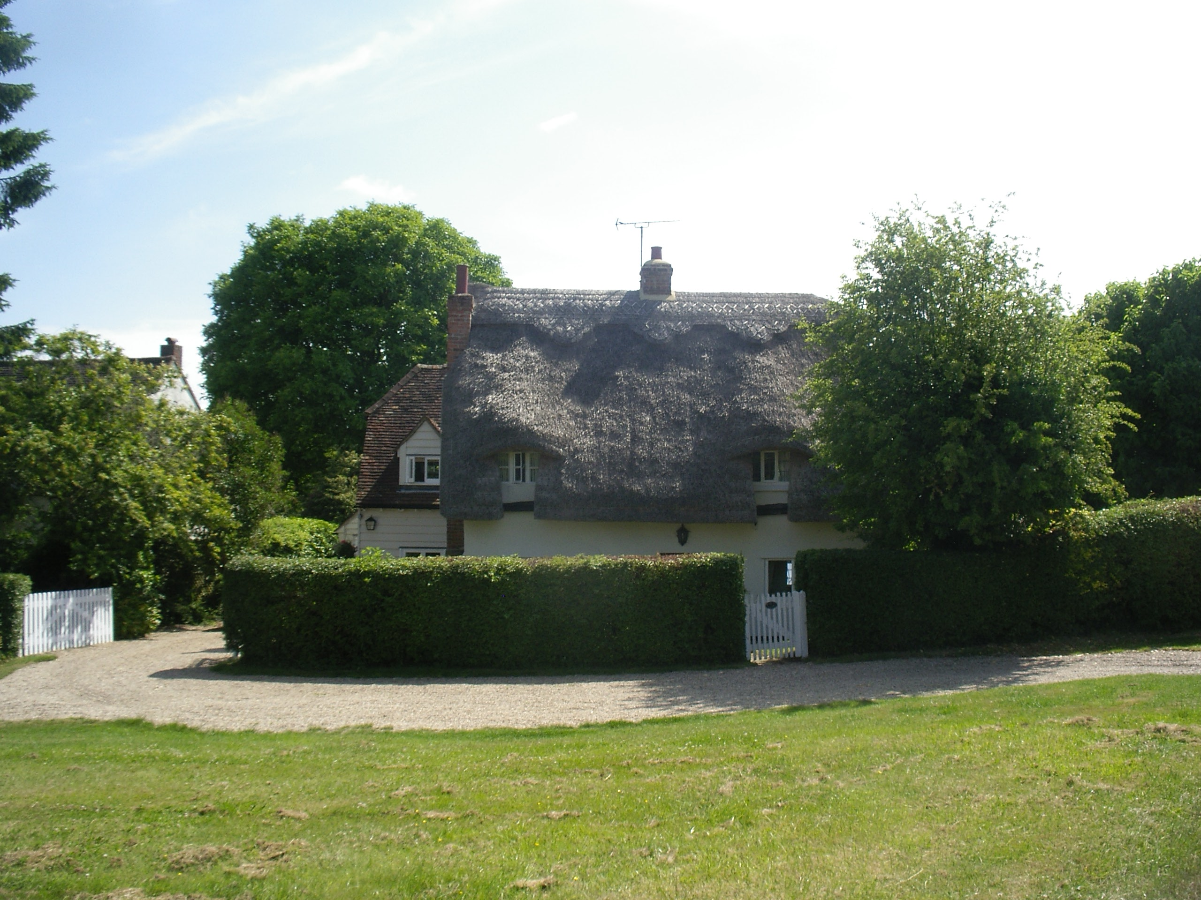

View some idyllic village scenes
& enjoy tales and tips on
the ancient art of thatching

Codicote Peace Memorial Hall
Tuesday 11 October 7.30 pm for 8.00 pm
FREE entry for members and just £3 for visitors!
Tel: 01438-821849 www.codicotelocalhistorysociety.co.uk
Explore your interest in history today!

