**CODICOTE LOCAL HISTORY SOCIETY**



**Think Back to 1980**

The world went mad for Rubik’s cube, Sony’s Walkman and Japan’s Pac-Man. We wore leg warmers and clothing inspired by the sports field (power dressing was still a few years away). On television we wondered who shot JR, watched Yes Minister and dreaded news of the Yorkshire Ripper, we went out to see The Shining, The Elephant Man and The Awakening.

Mrs Thatcher was Prime Minister and battling inflation rates that went up to 21.8%. Mount St. Helens erupted in Washington State and covered the world in ash. In 1980 we lost John Lennon, Alfred Hitchcock, Peter Sellers and Hattie Jacques, but welcomed into the world Venus Williams, Kim Kardashian, Rishi Sunak and Ashley Cole.

**Only Forty Years Ago, What a Different World!**

Here in Codicote, despite all these distractions, John Warwick found time to join Sue Maddex, her son Nicholas, Ted Elliott, Phyllis Doyle and Wendy Gaskin to form **Codicote’s own local history society**. Since then CLHS has hosted meetings, organised summer outings, researched and published local history and supported people with Codicote connections in their family history searches.

**40 Action-Packed Years**

So we are very sad to cancel our 40th anniversary celebrations and put all our activities that are open to the public on hold.

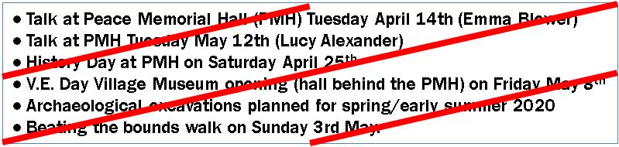**Events definitely cancelled (well, with luck only postponed):**

Later events (outings in June & July) are under review, we’ll let you know

**01438 821849** [**www.codicotehistory.org.uk**](http://www.codicotehistory.org.uk/)